**C64 Keyboard Controlled Kernal Switch Rev. 0**

**Wiring**

# Connections

There is one required connection, the Control Signals Cable. The Serial Cable to the USB/Serial-converter is optional and only required for uploading an Arduino sketch to the Kernal Switch.

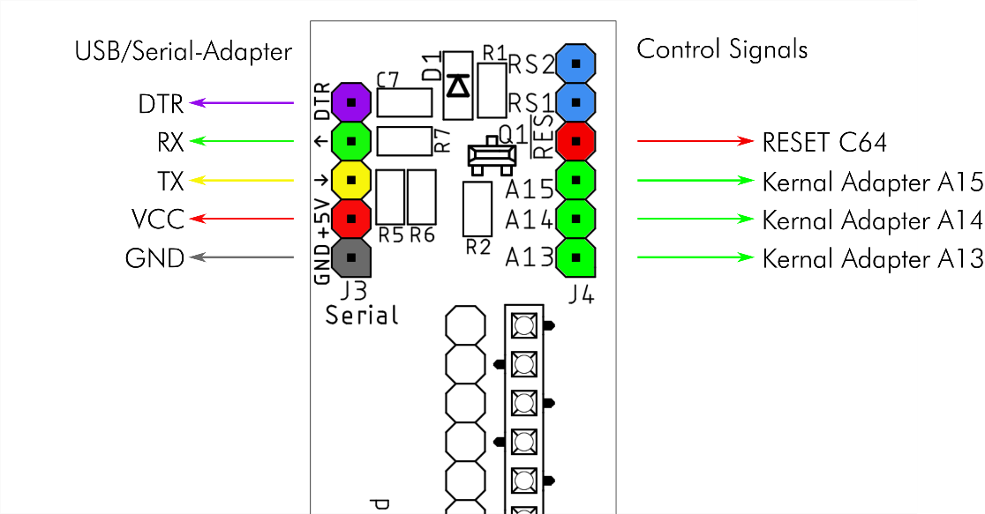

Figure 1: Connectors J3 and J4 of the Keyboard Controlled Kernal Switch

# Control Signal Cable

A wire connection between the keyboard controlled Kernal switch and the Kernal adapter is required to select the desired Kernal. Further on, the module has to reset the C64 after changing to that Kernal.

A recommended connector type is the wide spread Dupont connector. The contacts need to be crimped to the cable—this might be a challenge for some users.

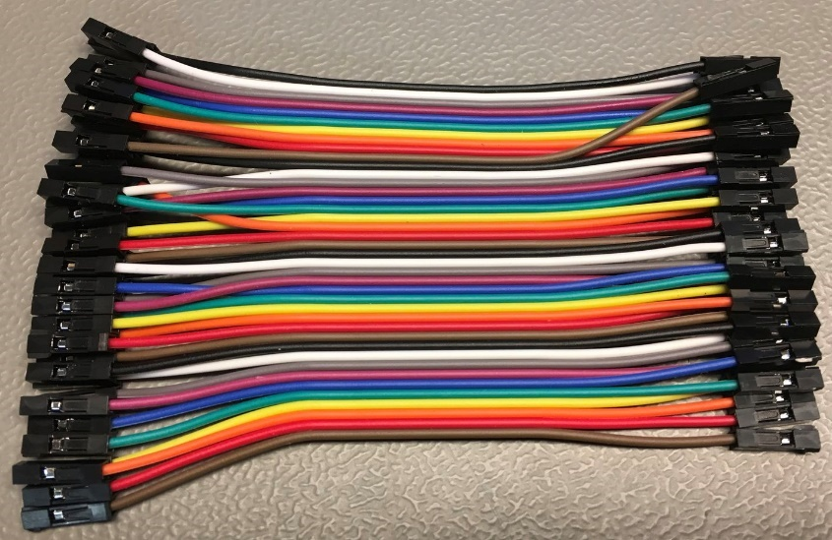

Figure 2: Prefabricated Dupont Cable

Alternatively, prefabricated Dupont cables (female–female) are readily available from eBay and are a suitable prefabricated solution. These prefabricated Dupont cables are usually sold as ribbon cables of up to 40 poles, each wire have an individual connector (Figure 2). The desired amount of wires can simply be peeled off of the ribbon cable. For the C64 short board, 30cm cables are required. For the C64 long board, 10cm cables are an adequate length.

An alternative may be receptacles which fit on pin headers with the cables soldered to them. The next possible solution might be leaving the pin headers on Kernal switch and Kernal adapter not populated and solder in the cables directly.

A pin header (one pin) on the RESET signal of the C64 is required to be soldered. This RESET contact can be found near the user port. Looking from the port side, it is the 3rd contact from the left on the top side. Note, it is not good practice to solder the pin directly at the contact, but rather to a solder pad or via near it.

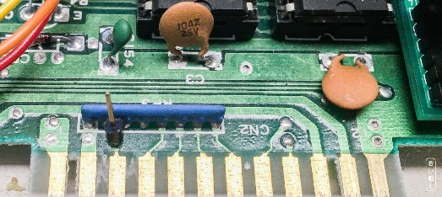

Figure 3: Reset Contact ASSY 250425 (identical to ASSY 250407) – Long Board

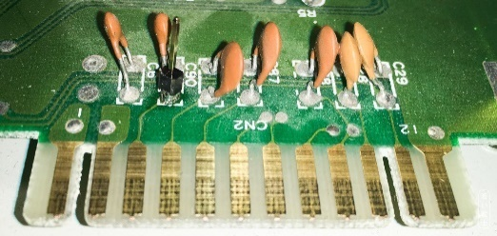

Figure 4: Reset Contact ASSY 250469 (front pin of C90) – Short Board

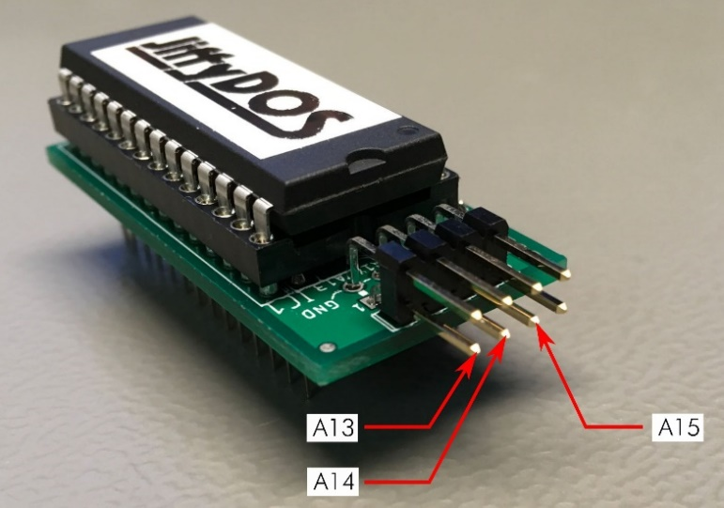

Figure 5: Connector of the Kernal Adapter

The required connections are:

|  |  |  |
| --- | --- | --- |
| Kernal Switch J4 | Kernal Adaptor JP1 | C64 Mainboard |
| A13 | A13 | - |
| A14 | A14 | - |
| A15 | A15 | - |
|  | - | RESET Pin (Figure 3 & Figure 4) |

Although the C64 *long boards* and C64 *short boards* require different Kernal adapters, both connectors are the same, as indicated in Figure 5.

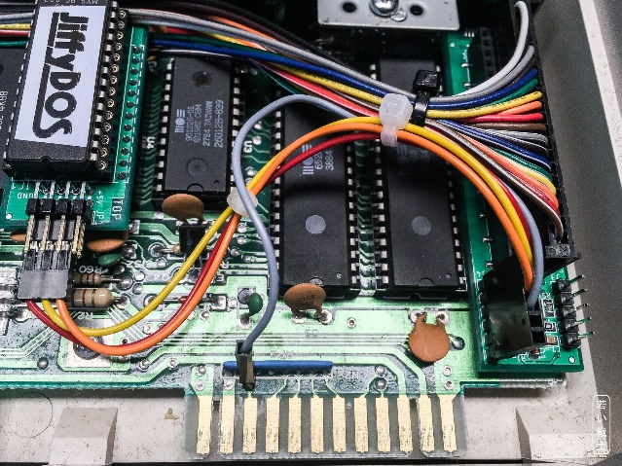

Figure 6: Wiring of ASSY 250425

Figure 6 shows the wiring of ASSY 250425 (ASSY 2502407 is similar). The grey cable is the reset signal, which is attached to the RESET pin header that was installed previously.

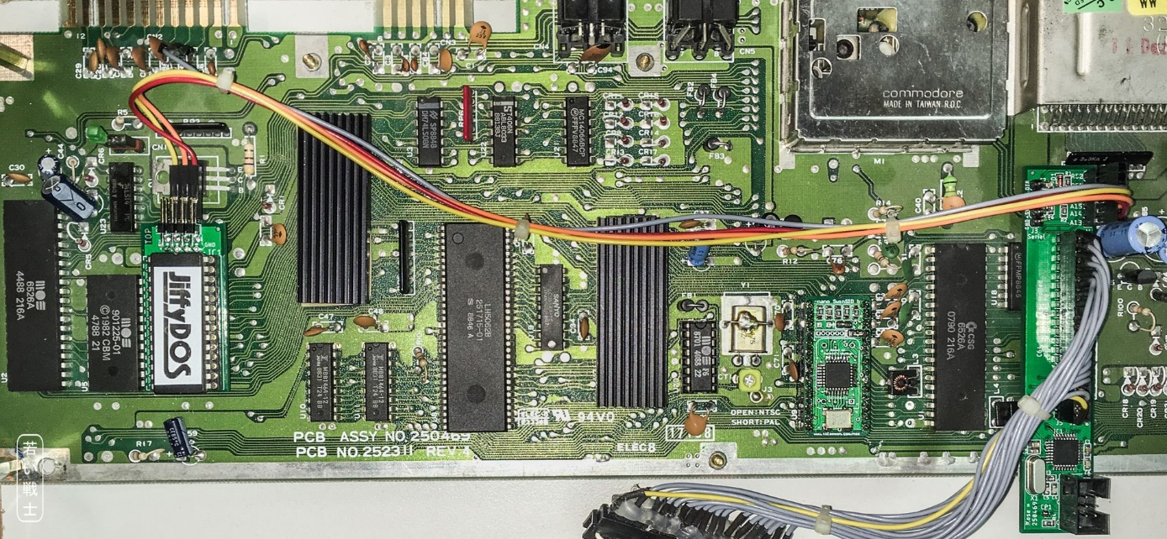

Figure 7: Wiring of ASSY 250469

Figure 7 shows the wiring of ASSY 250469 (*short board*). Again, the grey cable is the RESET signal, which is attached to the previously soldered RESET pin near the user port.

# Serial Cable

The Serial Cable can vary, depending on the used USB/Serial adapter board. An FT232 based adapter is recommended, which is widely used, provides +3.3V and 5V operation and driver software up to Windows 10.

The USB/Serial adaptor provides VCC (+5V) to the module. This is useful while programming the microcontroller but is not recommended if the module is inserted in the C64 and the computer is powered by it. In this case, the C64 would be powered via the USB interface of the computer. This will not damage the C64, however, for proper operation, the VCC should be interrupted or switched off. The serial interface can be helpful while debugging.

Again, the recommended connector type are Dupont connectors with the alternative of using receptacles, which also fit on standard pin headers. Direct soldering is not recommended.

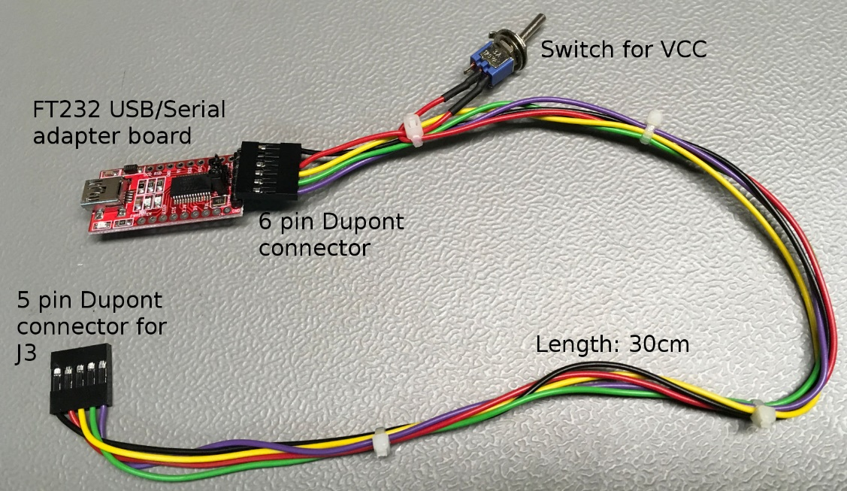

Figure 8: Serial Cable

Notice: During testing of the Kernal Switch, the C64 sometimes would not start. A ground loop was identified as the cause (mains → PC → USB → Adapter → Serial Cable → Kernal Switch → C64 → C64 Power Supply → mains). The power-on failure was resolved after interrupting the ground loop and the issue did not reoccur.